AI StudyBuddy
Proposed Solution
Solution Design Phase

Project | AI StudyBuddy
Project ID | SWTID-2026-7764
Prepared | 28 September 2026
Source | Current source folders: backend/ and client/
Document status | Project-specific draft based on current backend/client source evidence

Evidence baseline: current source files inspected from the backend/ and client/ folders. node_modules were not required. Claims not visible in source are labelled as implemented, partially implemented, proposed, unverified, or requiring verification.

Document Contents
- Solution Overview
- Implemented Modules
- Scope Boundaries

Solution Overview
The proposed solution is an authenticated web application with a React dashboard connected to an Express REST API. Students upload learning material, the backend extracts text and stores a Material document, and Gemini generates structured learning assets on demand.
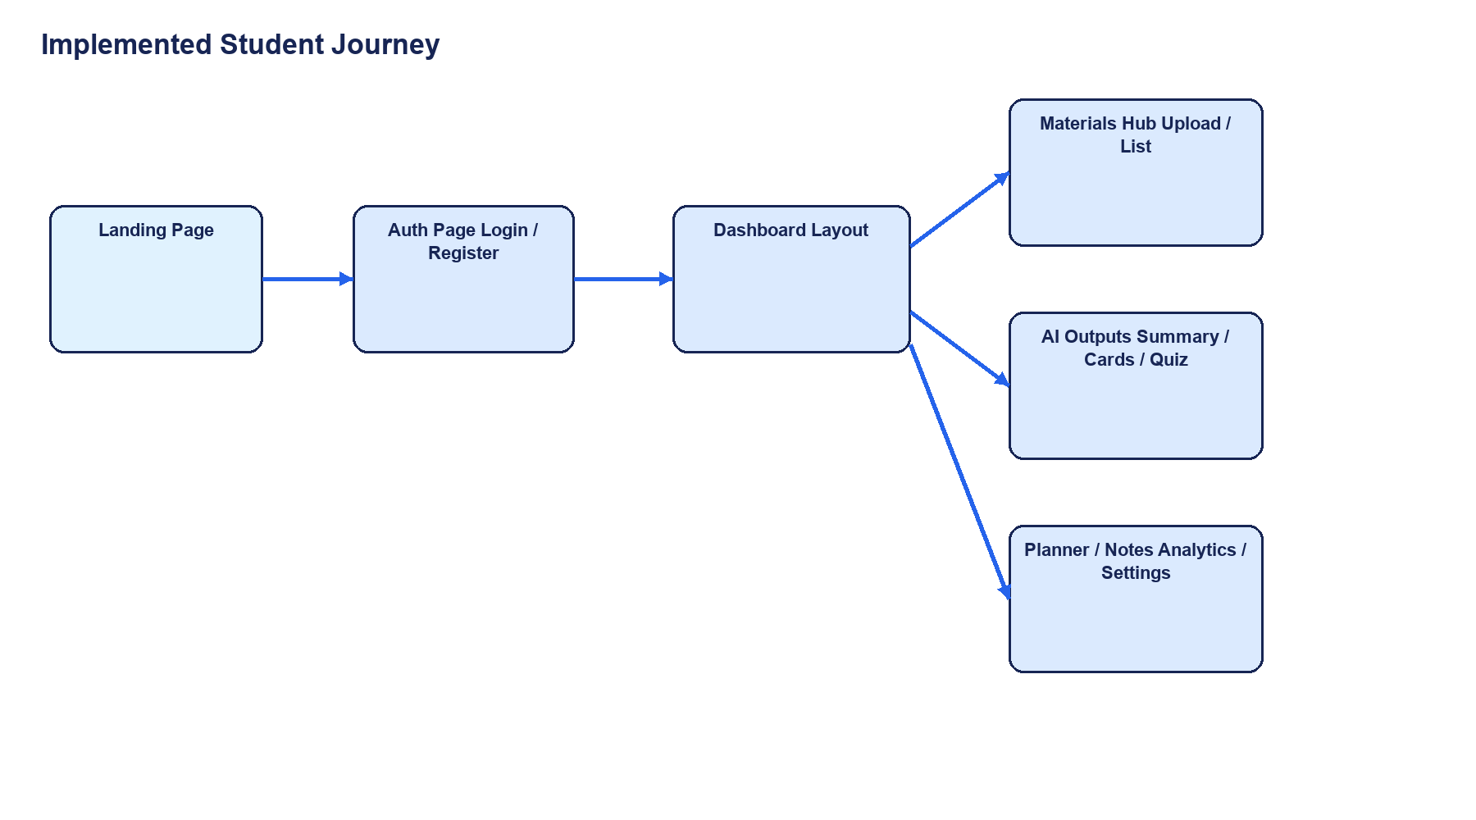
Primary user flow from landing page to learning assets and study utilities.

Implemented Modules
Module | Responsibility | Current state
Authentication | Register/login, JWT pair, bcrypt password verification, role claim | Implemented
Materials Hub | Upload, list, view, delete, filter, text entry | Implemented / UI integrated
AI generation | Summary, flashcards, quiz, study plan | Implemented through backend endpoints
Quiz Player | Question navigation, answer selection, score, explanations, confetti | Implemented in frontend
Study planning | Prioritized tasks, completion, deletion | Frontend interaction; persistence not evidenced
Smart Notes | Create, search, pin, favorite notes | Frontend interaction; persistence not evidenced
Analytics | Study metrics and mastery visualization | Frontend presentation; persistence not evidenced
Administration | Users, stats, cascade deletion | Backend API implemented; AdminPanel not found in selected current client source

Scope Boundaries
- In scope: current backend/ and client/ behavior and documented setup.
- Not assumed: Gmail/LinkedIn registration, email/OTP confirmation, payment, production hosting, CI/CD, or completed automated tests.
- Recommended next scope: verify the intended AdminPanel source, connect local-only study utilities to durable APIs, add test suites, and define production deployment.

